**Duty Types**

***Work-flow to Use Duty Types***

Use **Add Preference** to obtain a baseline dialog that sets Duty Types



Repeat **Add Preference** for additional instances of the baseline dialog



***Preference Overview***

This preference defines all of the possible duty types over a 24 hour period. To achieve full coverage you will need to use multiple instances - for example, Morning, Noon, Night , ... . To ensure that you have no gaps, there is a small fall-back section appended to preference.

The preference defines duties by setting up time constraints for work time and splits. The penalty field for each duty functions as a "duty cost".

Duty type appears in the Drivers Gantt:

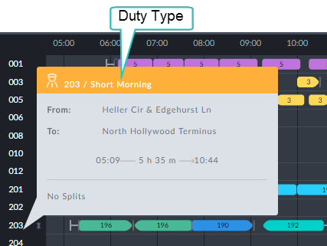

*Figure 1-1: Duty Block information box showing the Duty Type*

The Duty Types are intended to "guide" the Driver optimization If it creates a duty that it cannot match with a Duty Type, it will use the fall-back.

***Add Preference Dialog***

**Prerequisites:** None.

**Opening Dialog:**

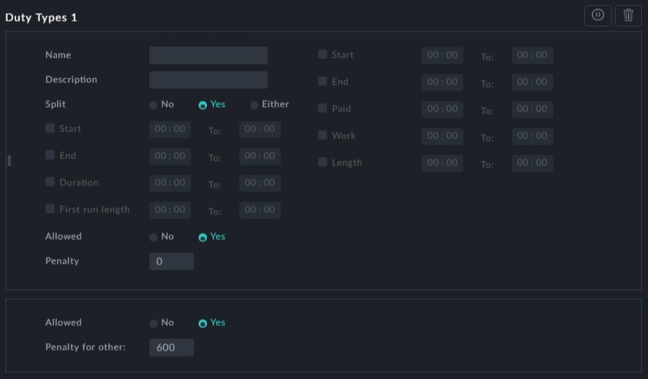

*Figure 1-2: Duty Types - Full dialog*

**Duty**: Enter a duty name. It appears in a Drivers Gantt information box as shown in **Figure 1-1** above. It also appears in the KPI histogram showing the number of duties by duty type. See **Distribution of Driver Duties by Duty Type**.

**Description** is optional.

Look at the right hand section of **Figure 1-1**:

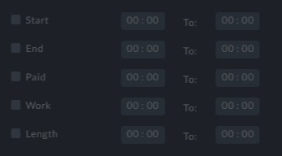

To enable any of these fields check the box to their left.



The following fields are expressed as ranges rather than as a single value

reflecting the purpose of the preference: To Guide the Optimizer rather than set rules like in the **Work Limitation** preference.

**Start** is the clock time range within which the duty must commence. For example,



**End** is the clock time range within which it must finish.

**Paid** is the paid time duration range of a duty.

**Work** is a range for the maximum duty shift time net of splits break time. **Length** is a range for the maximum duty shift time including split break times. Next, look at the left hand section of **Figure 1-1**:

**Split**: We can disallow a split break for thgis Duty Type by setting **Split** to No, resulting in a reduced display:

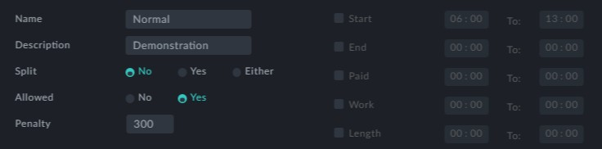

*Figure 1-3: Reduced Duty Types display - no split*

Setting **Split** to Either tells the Optimizer that we are indifferent to splits for this Duty

Type.

Setting **Splits** to Yes opens a further display segment to specify the split details:

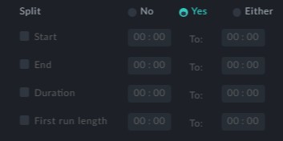

**Start** is the clock time range within which the split break time must commence. For example,



**End** is the clock time range within which it must finish.

**Duration** is the time interval range for the split break time.

We do not want a split break before a minimum amount of work time - the first run length.

**First run length** provides range for this Duty Type.

**Allowed** is set to Yes by default. It directs the Optimizer to allow this Duty Type when it can make a match. Setting it to No, directs the optimizer to disallow a duty matching this Duty Type.

**Penalty**: The penalty is the cost of using this Duty Type.

**The fall-back Display:**

The fall-back section appears at the bottom of all instances of this preference. It is the small panel at the bottom of **Figure 1-1**:

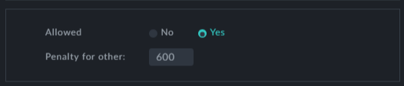

It is a default duty type to fill out gaps in any 24 hour period. You can prevent its use by setting **Allowed** to No. You can also set a penalty for using it.



Disallowing the fall-back is not advised.

Here is what the fall-back looks like at the end of an actual Duty Types Preference:

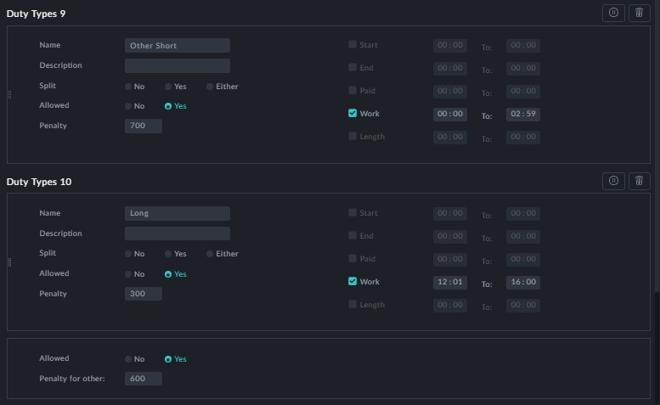

This particular schedule uses eight out of 10 named Duty Types, which appear in the

Duty types KPI Histogram (see **Distribution of Driver Duties by Duty Type**):

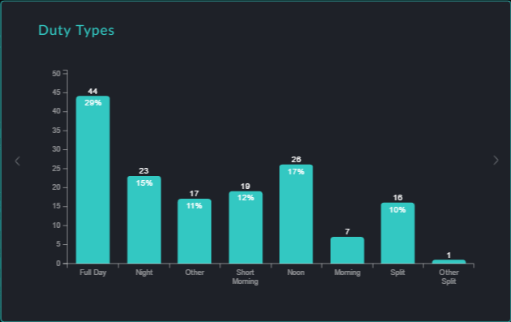

**Points to note:**

You may create additional instances of this preference for different Duty Types. However, there are no Edit Filters and you should take care to ensure consistency



between instances.

There are currently no additional Optibus templates available

